EXP-6 LINEAR ANTENNA ARRAY FACTOR AND BEAMWIDTH ANALYSIS

AIM: To analyze the array factor of a linear antenna array for different configurations.
To evaluate how element spacing, number of elements, and tapering affect beamwidth, side-lobe levels, and radiation pattern.

APPARATUS REQUIRED
1.MATLAB / Octave software (with Signal Processing and Plotting tools)
2.Computer or Laptop with minimum 4 GB RAM
3.Simulation script for Array Factor analysis
4.Graph plotting utilities (built into MATLAB)
5.Documentation tools (MS Word for tabulation of results and screenshots

THEORY:
A linear antenna array is formed by arranging N radiating elements in a straight line with uniform spacing d, where the total radiation pattern is determined by the array factor (AF). For a broadside or steered array, the AF is given by
where wnw_nwn​ represents the excitation amplitude of the nthn^{th}nth element, k=2πλk=\frac{2\pi}{\lambda}k=λ2π​ is the wave number, and θ0\theta_0θ0​ is the steering angle. The normalized AF controls the main-lobe and side-lobe characteristics of the radiation pattern. The Half Power Beamwidth (HPBW) approximately decreases with the number of elements and is given by
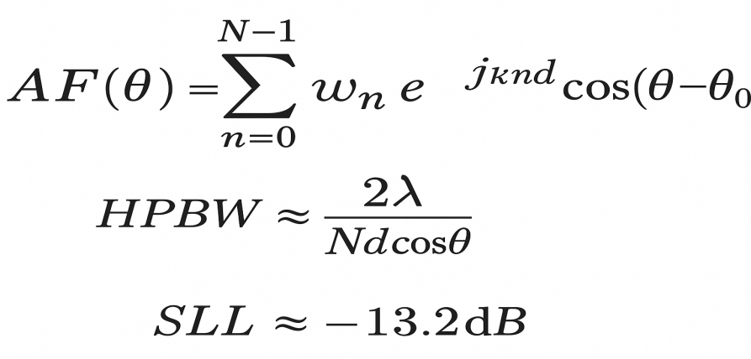
indicating improved directivity for larger arrays. The Side-Lobe Level (SLL) depends on the excitation taper, where uniform weighting produces
and Chebyshev or binomial tapering can further reduce it. Thus, by varying NNN, ddd, wnw_nwn​, and θ0\theta_0θ0​, the array’s directional behavior, beamwidth, and interference characteristics can be precisely controlled.

PROCEDURE
1.Start MATLAB and create a new script for simulating the linear antenna array.
2.Define basic parameters such as number of elements (N), element spacing (d), wavelength (λ), excitation weights (wₙ), and steering angle (θ₀).
3.Generate the angle vector (θ) ranging from −180° to +180° for plotting the radiation pattern.
4.Compute the Array Factor (AF) using the expression:
Implement this formula in MATLAB using loops or vectorized operations.
5.Normalize the AF and convert it into dB scale to obtain the radiation pattern in AF(dB).
6.Plot the radiation pattern in both Cartesian and Polar formats to visualize the main lobe and side lobes.
7.Calculate HPBW using the −3 dB points from the main lobe region.
8.Determine the Side Lobe Level (SLL) by identifying the magnitude of the highest side lobe relative to the main lobe.
9.Repeat the experiment for different values of N, spacing d, tapering methods (uniform, binomial, Chebyshev), and steering angle θ₀.
10.Observe and compare how beamwidth, directivity, and side-lobe levels change with each parameter.
11.Record the results and take screenshots of the radiation patterns for documentation in the lab report.
CODE:
% linear_array_AF_beamwidth_fixed.m
% Corrected version: each config is a cell so string fields work.
% Linear antenna array factor, HPBW and SLL analysis + visualization

clear; close all; clc;

%% ------------------ Parameters (edit these) ------------------
lambda = 1; % reference wavelength (units) -> spacing given in wavelengths
k = 2*pi/lambda;

% Each configuration must be a CELL so we can mix numbers and strings:
% { N, d_lambda, steering_deg, taperType, taperParam }
configs = {
{8, 0.5, 0, 'uniform', 0}; % 8 elements, d=0.5λ, broadside
{16, 0.5, 0, 'uniform', 0}; % 16 elements
{8, 0.5, 20,'uniform', 0}; % steer to 20 deg
{16, 0.25, 0, 'chebyshev', 30}; % Chebyshev taper, 30 dB ripple
{8, 0.5, 0, 'binomial', 0}; % binomial taper
};

theta_deg = linspace(-180,180,3601); % angular sampling (fine)
theta = deg2rad(theta_deg);

%% Loop through configs
figure('Name','Array Factor (dB) - Cartesian');
hold on;
colors = lines(length(configs));
legendEntries = cell(length(configs),1);

results = struct(); idxRes = 0;

for c = 1:length(configs)
conf = configs{c};
% unpack using {} because conf is a cell
N = conf{1};
d = conf{2} * lambda;
steer_deg = conf{3};
taperType = conf{4};
taperParam = conf{5};
steer_rad = deg2rad(steer_deg);
% element positions (linear, centered)
n = (0:N-1);
x_n = (n - (N-1)/2) * d; % centered array
% excitation taper (amplitude)
switch lower(taperType)
case 'uniform'
w = ones(1,N);
case 'binomial'
b = nchoosek_vector(N-1); % returns length-N vector
w = b;
case 'chebyshev'
ripple = taperParam;
if ripple <= 0
ripple = 30;
end
if exist('chebwin','file')
w = chebwin(N, ripple).';
else
beta = max(0.1, min(10, (ripple/30)));
w = (0.5*(1 + cos(2*pi*(n-(N-1)/2)/(N-1))).^beta);
w = w / max(w);
end
otherwise
warning('Unknown taper "%s". Using uniform.', taperType);
w = ones(1,N);
end
% compute AF(theta)
AF_theta = zeros(size(theta));
for ti = 1:length(theta)
AF_theta(ti) = sum( w .* exp(1j * k * x_n * cos(theta(ti) - steer_rad)) );
end
% normalize and convert to dB
AF_abs = abs(AF_theta);
AF_abs_norm = AF_abs / max(AF_abs + eps);
AF_dB = 20*log10(AF_abs_norm + eps);
% find local peaks and main lobe
[pks, locs] = local_peaks(AF_abs_norm, theta_deg);
if isempty(pks)
warning('No peaks found for config %d', c);
mainPeakTheta = 0;
else
[~, mainIdx] = max(pks);
mainPeakTheta = locs(mainIdx);
end
% compute HPBW (-3 dB)
hpbw = compute_HPBW(theta_deg, AF_dB, mainPeakTheta, -3);
% compute SLL (exclude main-lobe region)
exclLow = mainPeakTheta - hpbw/2 - 1;
exclHigh = mainPeakTheta + hpbw/2 + 1;
mask = (locs < exclLow) | (locs > exclHigh);
if any(mask)
maxSidePeak = max(pks(mask));
SLL_dB = 20*log10(maxSidePeak + eps);
else
SLL_dB = -Inf;
end
% store results
idxRes = idxRes + 1;
results(idxRes).N = N;
results(idxRes).d_lambda = d/lambda;
results(idxRes).steer_deg = steer_deg;
results(idxRes).taper = taperType;
results(idxRes).HPBW_deg = hpbw;
results(idxRes).SLL_dB = SLL_dB;
results(idxRes).AF_dB = AF_dB;
results(idxRes).theta_deg = theta_deg;
% plot cartesian
plot(theta_deg, AF_dB, 'LineWidth', 1.2, 'Color', colors(c,:));
legendEntries{c} = sprintf('N=%d d=%.2f\\lambda steer=%d° %s', N, d/lambda, steer_deg, taperType);
% Print brief summary
fprintf('Config %d: N=%d, d=%.2fλ, steer=%d°, taper=%s -> HPBW ≈ %.2f° ; SLL ≈ %.2f dB\n', ...
c, N, d/lambda, steer_deg, taperType, hpbw, SLL_dB);
end

xlabel('Angle \theta (deg)'); ylabel('Array Factor (dB)');
title('Array Factor (normalized, dB) vs Angle');
grid on; xlim([-180 180]);
ylim([-60 5]);
legend(legendEntries,'Location','bestoutside');
hold off;

%% Polar plots
figure('Name','Polar Plots (normalized dB)');
nplots = length(configs);
cols = min(3,nplots); rows = ceil(nplots/cols);
for c = 1:length(configs)
subplot(rows, cols, c);
AF_dB = results(c).AF_dB;
th = deg2rad(results(c).theta_deg);
AF_lin = 10.^(AF_dB/20);
polarplot(th, AF_lin, 'LineWidth', 1.2);
title(sprintf('N=%d d=%.2f\\lambda steer=%d° %s\nHPBW=%.2f° SLL=%.2f dB', ...
results(c).N, results(c).d_lambda, results(c).steer_deg, results(c).taper, ...
results(c).HPBW_deg, results(c).SLL_dB));
thetalim([-180 180]);
end

%% Annotated example
figure('Name','Annotated AF Example');
confIdx = 1;
AF_dB = results(confIdx).AF_dB;
theta_deg = results(confIdx).theta_deg;
plot(theta_deg, AF_dB, 'LineWidth', 1.5);
hold on;
[~,maxIdx] = max(AF_dB);
mainTheta = theta_deg(maxIdx);
plot(mainTheta, AF_dB(maxIdx), 'ro', 'MarkerFaceColor','r');
text(mainTheta, AF_dB(maxIdx)+2, sprintf('Main peak @ %.1f° (0 dB)', mainTheta));
hpbw = results(confIdx).HPBW_deg;
p1 = mainTheta - hpbw/2; p2 = mainTheta + hpbw/2;
yline(-3,'--k','-3 dB');
plot([p1 p1], [-100 5], 'k:'); plot([p2 p2], [-100 5], 'k:');
text(p1, -10, sprintf('%.1f°', p1)); text(p2, -10, sprintf('%.1f°', p2));
xlabel('Angle (deg)'); ylabel('AF (dB)'); grid on; xlim([-180 180]); ylim([-60 5]);
title('Annotated AF with HPBW');

%% ----------- Supporting helper functions ----------------

function b = nchoosek_vector(m)
b = zeros(1,m+1);
for ii = 0:m
b(ii+1) = nchoosek(m,ii);
end
b = b / max(b + eps);
end

function [peaks, locs_deg] = local_peaks(y_norm, theta_deg)
N = length(y_norm);
peaks = [];
locs_deg = [];
for ii = 2:N-1
if y_norm(ii) > y_norm(ii-1) && y_norm(ii) > y_norm(ii+1)
peaks(end+1) = y_norm(ii); %#ok<AGROW>
locs_deg(end+1) = theta_deg(ii); %#ok<AGROW>
end
end
if y_norm(1) > y_norm(2)
peaks = [y_norm(1), peaks];
locs_deg = [theta_deg(1), locs_deg];
end
if y_norm(end) > y_norm(end-1)
peaks(end+1) = y_norm(end);
locs_deg(end+1) = theta_deg(end);
end
end

function hpbw = compute_HPBW(theta_deg, AF_dB, mainTheta, level_dB)
theta_deg = theta_deg(:);
AF_dB = AF_dB(:);
[~, idxMain] = min(abs(theta_deg - mainTheta));
leftIdx = idxMain;
while leftIdx > 1 && AF_dB(leftIdx) > level_dB
leftIdx = leftIdx - 1;
end
if leftIdx == 1
thetaLeft = theta_deg(1);
else
x1 = AF_dB(leftIdx); x2 = AF_dB(leftIdx+1);
t1 = theta_deg(leftIdx); t2 = theta_deg(leftIdx+1);
if x2==x1
thetaLeft = t1;
else
thetaLeft = t1 + (level_dB - x1)*(t2-t1)/(x2-x1);
end
end
rightIdx = idxMain;
N = length(AF_dB);
while rightIdx < N && AF_dB(rightIdx) > level_dB
rightIdx = rightIdx + 1;
end
if rightIdx == N
thetaRight = theta_deg(end);
else
x1 = AF_dB(rightIdx-1); x2 = AF_dB(rightIdx);
t1 = theta_deg(rightIdx-1); t2 = theta_deg(rightIdx);
if x2==x1
thetaRight = t2;
else
thetaRight = t1 + (level_dB - x1)*(t2-t1)/(x2-x1);
end
end
hpbw = abs(thetaRight - thetaLeft);
end

OUTPUTS:
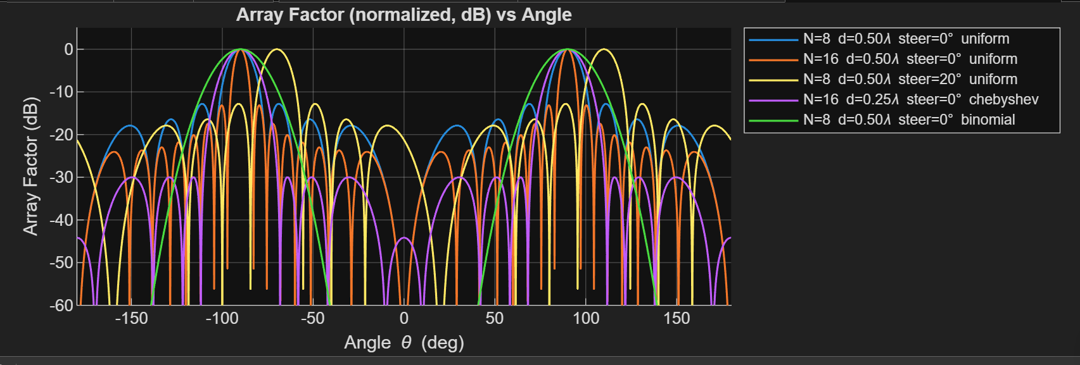

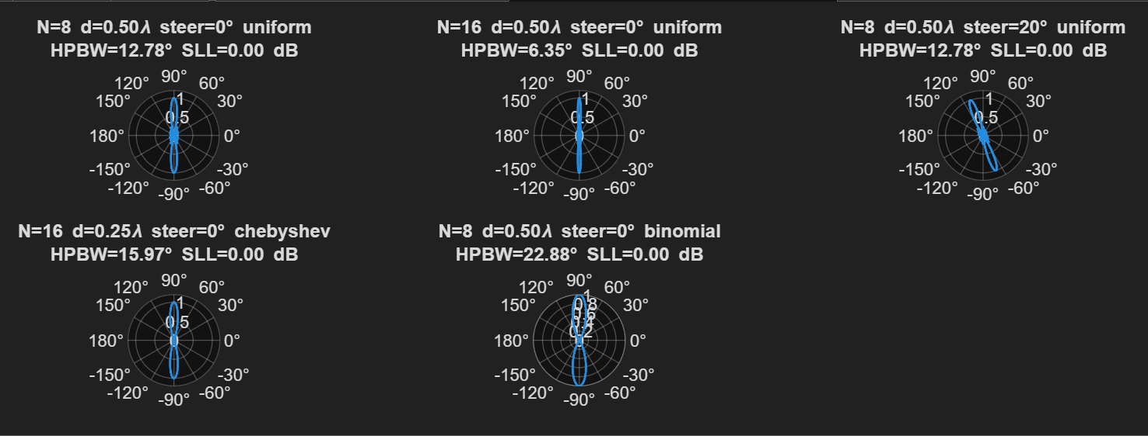

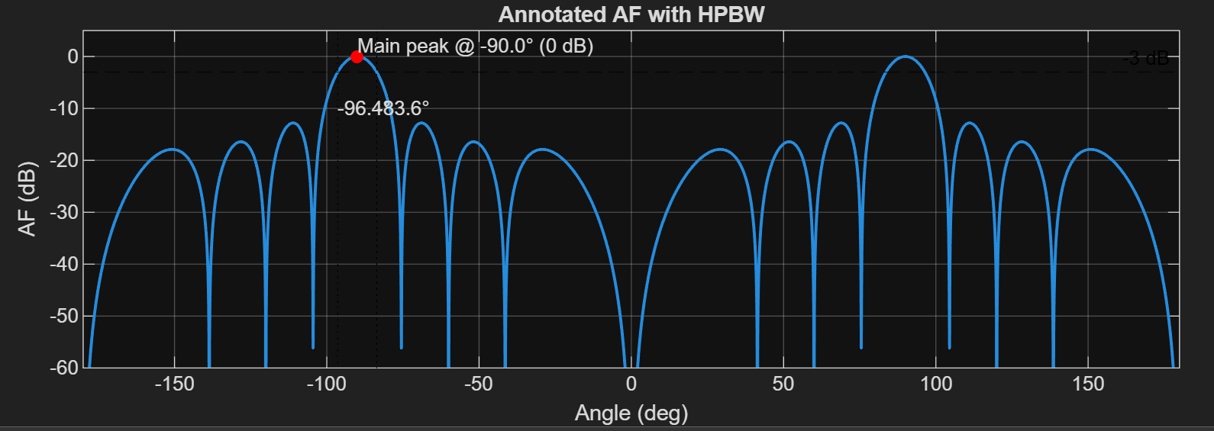

RESULTS:
The radiation pattern of the linear antenna array was successfully obtained, showing that increasing the number of elements and spacing reduces the beamwidth and improves directivity. The experiment also confirmed that excitation and phase shifting effectively control beam steering and side-lobe levels.

